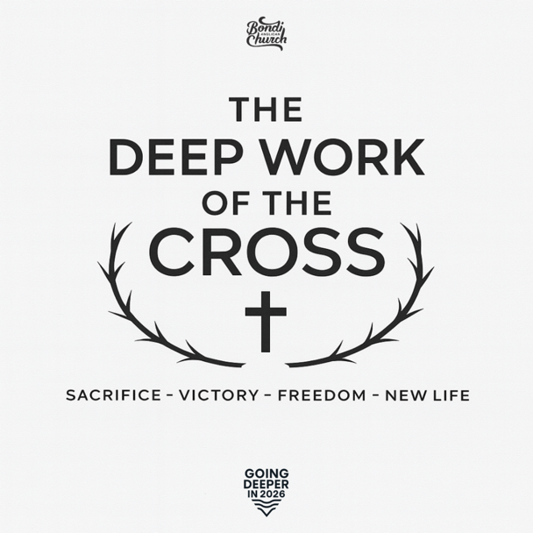
As our church continues the journey of Deeper in 2026, this Easter series invites us to behold the deepest reality at the centre of Christian faith: the death and resurrection of Jesus Christ. If we want to grow in maturity, strength, and spiritual depth, we must root ourselves in the gospel’s greatest moment — the moment when Jesus went to the lowest depths so that we could be lifted into new life. The cross and empty tomb are not only historical events; they are the deep well from which every part of Christian life flows. “The Deep Work of the Cross” is a four-week movement that begins at Good Friday and follows through to the resurrected life Jesus gives His people. The series leads us from the depth of His sacrifice to the depth of His victory, to the depth of our freedom, and finally to the depth of our new life and mission. We begin by slowing down to see the cost of our salvation — the suffering Servant who willingly bore our sin. From here, Easter Sunday erupts with the triumphant news that death has been defeated, and hope has dawned. The following weeks then explore what the gospel accomplishes in us: breaking the power of sin, forming us into new creations, and sending us as ambassadors of reconciliation. This series clarifies a vital truth for our church in 2026: going deeper is not about trying harder but about sinking our lives into the saving work of Jesus. The deeper we go into the cross, the deeper God grows us in maturity. The deeper we understand the resurrection, the deeper we live in freedom and purpose. The gospel is not the starting point of the Christian life — it is the Christian life. Everything else flows from here.
Our goal throughout this series is to help our church:
- Behold the depth of Christ’s sacrifice with renewed awe
- Celebrate the depth of His victory with joy and hope
- Embrace the depth of freedom and transformation He offers
- Live out the depth of our new identity and mission in Him
By the end, we pray that our people won’t simply understand the cross more deeply but will experience its power more deeply — in their hearts, their habits, their relationships, and their calling.
This Easter, we go deeper by returning to the centre.
Date | Title
3/04/2026 | The Depth of His Sacrifice
5/04/2026 | The Depth of His Victory
12/04/2026 | The Depth of Our Freedom
19/04/2026 | Guest Speaker from OpenDoors
26/04/2026 | The Depth of Our New Life

