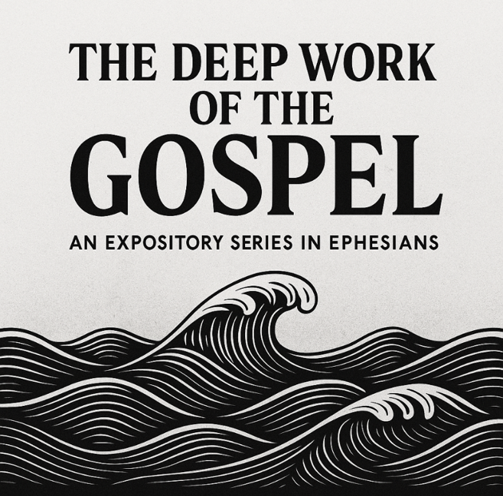
Ephesians: The Deep Work of the Gospel invites our church to see just how far and how deep the good news of Jesus truly goes. Paul’s letter begins not with what we must do, but with what God has already done — blessing us, choosing us, redeeming us, adopting us, and sealing us in Christ. The gospel does not skim the surface of our lives; it reaches into the deepest parts of our identity, our community, and our calling. In Ephesians, we discover that God is not just making better people but a new humanity in Christ, filled with His power and grounded in His love. As we step further into our church-wide vision of Deeper in 2026, this series helps us see that depth is not something we produce by trying harder. Depth is something God works in us through the gospel. Ephesians shows that the Christian life begins with God’s initiative and continues with God’s strength. When the gospel does its deep work — forming our identity, healing our divisions, strengthening our inner being, maturing our walk, and equipping us for spiritual resilience — we become a people rooted and established in love, living lives worthy of our calling. This series aims to help our church move beyond surface-level Christianity and into the fullness that Paul prays for: “that you may be filled to the measure of all the fullness of God.” We want to grow as disciples who not only understand the gospel but are shaped, stretched, and strengthened by it — in our homes, our relationships, our workplaces, and our community. As we journey through Ephesians, our prayer is that God would take us deeper into His grace, deeper into His love, and deeper into the new life He has called us to live together as His church.

Date | Title
3/05/2026 | The Depth of God’s Blessing
10/05/2026 | The Depth of God’s Power
17/05/2026 | From Death to Life
24/05/2026 | The Depth of Reconciliation
31/05/2026 | The Depth of God’s Mystery
07/06/2026 | The Depth of Christ’s Love
14/06/2026 | Walking in Depth
21/06/2026 | Live a life worthy in daily life
28/08/2026 | Standing Firm in the Depths
05/07/2026 | Ephesians 5:1-18
12/07/2026 | Ephesians 5:15-20 & Colossians 3:15-17
19/07/2026 | Submission #1: The Good, The Bad, and the Ugly
26/07/2026 | Submission #2: How to react to Masters. Submission in Society
02/08 2026 | Filimone
09/08/2026

