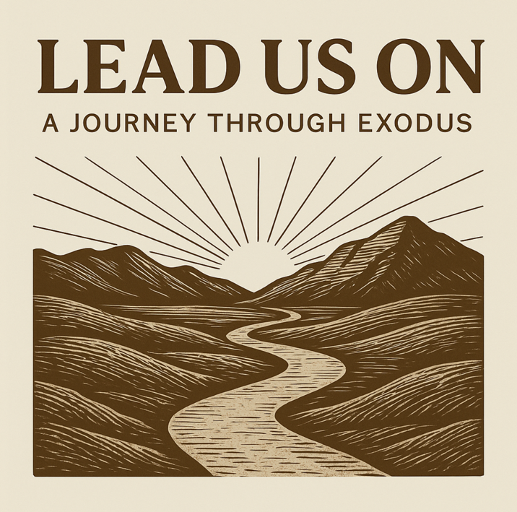
Lead Us On: A Journey Through Exodus invites our church to walk with the people of God as they move from slavery to freedom, from fear to faith, and from knowing about God to learning to walk with Him. Exodus is not just an ancient story — it is the pattern of the Christian life. God sees His people in their pain, calls them into His purposes, delivers them with power, provides for them in the wilderness, forms them at the mountain, forgives them when they fail, and leads them ultimately by His presence. This story is the story of every disciple who is learning to trust God more deeply. As we continue in our vision of Deeper in 2026, Exodus reminds us that spiritual depth is not gained in comfort but in journeying with God. Depth is formed when we trust Him in affliction, obey Him when His call disrupts our plans, stand firm when the waters rise, depend daily on His provision, and seek His presence above all else. Exodus reveals a God who not only saves but stays — who leads His people step by step into a life shaped by His grace, commands, and presence. Our goal in this series is to see our church grow as a people who follow God with courage and faith. We want to learn what it means to live as God’s redeemed people — to reject the idols that enslave us, embrace the rhythms of trust and obedience, and cultivate a life centred on God’s presence. As we journey through Exodus together, our prayer is that God would “lead us on,” taking us deeper into His freedom, deeper into His character, and deeper into the life He is calling us to live.

Date | Title
16/08/2026 | God in the Midst of Slavery
23/08/2026 | God Calls from the Fire
30/08/2026 | The God Who Delivers
06/09/2026 | Through the Deep Waters
13/09/2026 | Bread from Heaven, Water from the Rock
20/09/2026 | COMPASSION
27/09/2026 | Meeting God at the Mountain
04/10/2026 | The Covenant and the Golden Calf
11/10/2026 | God’s Presence Goes with Us

